Code # BU04 (2014)
Bulletin Change Transmittal Form
☒ Undergraduate Curriculum Council - Print 1 copy for signatures and save 1 electronic copy.
☐ Graduate Council - Print 1 copy for signatures and send 1 electronic copy to pheath@astate.edu
Bulletin Change
Please attach a copy of all catalogue pages requiring editorial changes.

Jollean Sinclaire 9/24/2014  Department Curriculum Committee Chair | ___________________ Enter date…  COPE Chair (if applicable)
___________________ Enter date…  Department Chair: | ___________________ Enter date…  General Education Committee Chair (If applicable)
___________________ Enter date…  College Curriculum Committee Chair | ___________________ Enter date…  Undergraduate Curriculum Council Chair
___________________ Enter date…  College Dean | ___________________ Enter date…  Graduate Curriculum Committee Chair
___________________ Enter date…
Vice Chancellor for Academic Affairs

1.Contact Person (Name, Email Address, Phone Number)
Jollean Sinclaire, ASU / CIT Department, Box 130, State University, AR 72467 jsinclaire@astate.edu (870) 972-3416

2.Proposed Change
Require “C” or better in Information Technology Component courses for Certificate in Business Information Systems.

3.Effective Date
Immediately

4.Justification
It is reasonable to require “C” or better in the three information technology courses (CIT core courses) that are required for this certificate in Business Information Systems.

Page 141
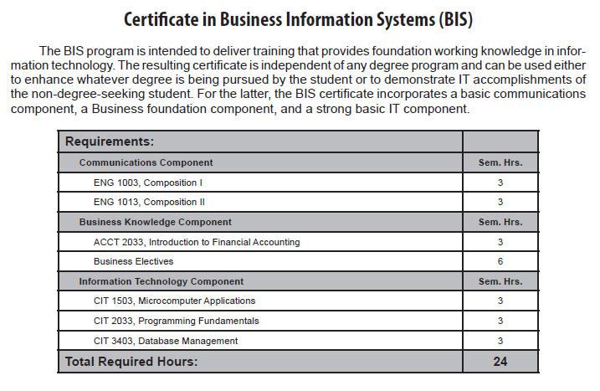
Current page 141:
Information Technology Component

Change highlighted section to:
Grade of “C” or better required for courses in the
Information Technology Component

